Business Agility: Benefits and challenges to Cloud architecture

FAQs
What Is Agility in Cloud Computing?
It is the ability of a business to respond and grow in an evolving market. This means the organization must be reliable, adaptable, and customer-centered to meet current market conditions.
What Is an Example of Agility in the Cloud?
Scalability in the provision of resources is an excellent example of agility. Here is a scenario: For a business to deal with high volumes of online traffic, it can install different virtual machines during peak hours. On the other hand, it can reduce their size during low-traffic hours.
What Are the Principles of Business Agility?
There are several principles, but the main one is the guiding theory that businesses can emulate to adapt to the ever-changing market conditions. Some common ones are flexibility, transparency, modernization, partnership, and more.
Why Is Cloud Agile?
There are several reasons why the cloud is agile. Some of which are flexibility, collaboration tools, scalability, and more. The best part about these features is that they help businesses evolve to market conditions and cut down on operational costs.
SHARE
Back to blog

Cloud Agility: What is it and What are the Benefits

For some business practices, endurance and consistency are the name of the game. However, there comes a time when organizations need to examine what they’ve been doing and find opportunities to move faster to maintain a competitive edge. Cloud agility can help businesses that are looking for greater flexibility, scalability, and development efficiency, among other things. In this article, we’ll discuss cloud agility – what it is, why it’s important, and how to build agility in your organization.
What is Cloud Agility?
Cloud agility allows businesses to create, launch, and test their applications quickly in a cloud-based environment. When an organization is agile, it’s able to respond rapidly and effectively to new business challenges or changing technological environments. Agility is a key component of cloud computing and enables organizations to respond appropriately to user demands.
Why is Cloud Agility Important for Businesses?
Companies that remain stagnant run the risk of losing business over time to competitors that are offering products and services that customers have grown to want. Cloud agility is important for business because of what’s provided in a cloud environment.
Organizations are able to iterate and progress more quickly in a cloud environment, improving the chances of relevancy and profitability, than in a traditional on-premises environment.
Benefits of Achieving Cloud Agility
Achieving cloud agility offers several business-friendly benefits, including accelerating the time to market, increasing flexibility, and enhancing organizational value.
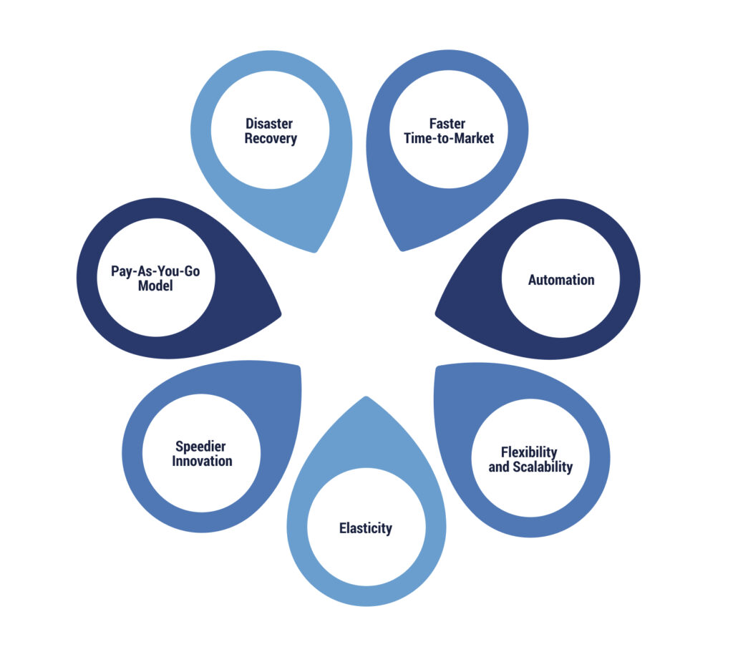
Faster Time-to-Market
The iterative nature of cloud computing gives businesses the chance to develop and launch an application and bring it to market, improving it over time. This cuts down on the delay between development and launch that may be present in an on-premises environment, where bringing something to market can require more lift from a business. Instead of taking weeks to procure and provision IT infrastructure, for example, cloud servers can accomplish this in minutes.
Automation
Automating routine tasks in a cloud environment can free up time on IT teams for other, more important tasks. Through automation, businesses are also able to reduce the number of errors from manual entry and oftentimes reduce the cost of labor associated with mundane, repetitive tasks, such as provisioning, scaling, and managing of resources.
Flexibility and Scalability
Whether it’s automated or not, businesses can easily scale their IT resources up or down to respond appropriately to demands. The flexibility of paying for what you use is not possible in an on-premises environment.
Elasticity
Cloud platforms offer elasticity, which means resources can be automatically adjusted to match demand. Businesses can put rules in place to trigger an increase or decrease that react to changes in demands on the system.
For example, if a website has an unexpected surge in traffic, the cloud infrastructure can automatically allocate more resources to handle the increased load to prevent the site from crashing.
Speedier Innovation
Cloud services offer access to various tools and technologies, like machine learning, big data analytics, and IoT platforms.This allows for innovation by letting organizations experiment with new technologies without substantial costs initially; it also accelerates their time-to-market and helps product improvements to be launched more quickly.
Pay-As-You-Go Model
Cloud services operate according to an OpEx model rather than CapEx. This pay-as-you-go or pay-per-use model, enables organizations to pay solely for the resources they utilize. This cost-efficient approach eliminates the necessity for substantial upfront investments in hardware and software, which gives IT leaders the opportunity to invest their former CapEx budget into other areas.
Disaster Recovery
Cloud agility includes the ability to establish resilient disaster recovery and backup solutions that safeguard critical data and operations. Through the cloud’s infrastructure, data can be efficiently replicated across multiple geographical regions and availability zones. This strategic redundancy ensures the continuity of essential business functions even in the face of unexpected failures, disasters, or disruptions. Cloud computing’s flexibility empowers organizations to customize disaster recovery plans, fine-tuning them to meet specific recovery time and recovery point objectives, thus enhancing overall business resilience.
What Are the Challenges with Cloud Agility?
When organizations are new to cloud computing, one of the main challenges can result from the culture and process shift to a new type of environment. Enhancing agility in the cloud also calls for an increased need for businesses to be agile in turn.
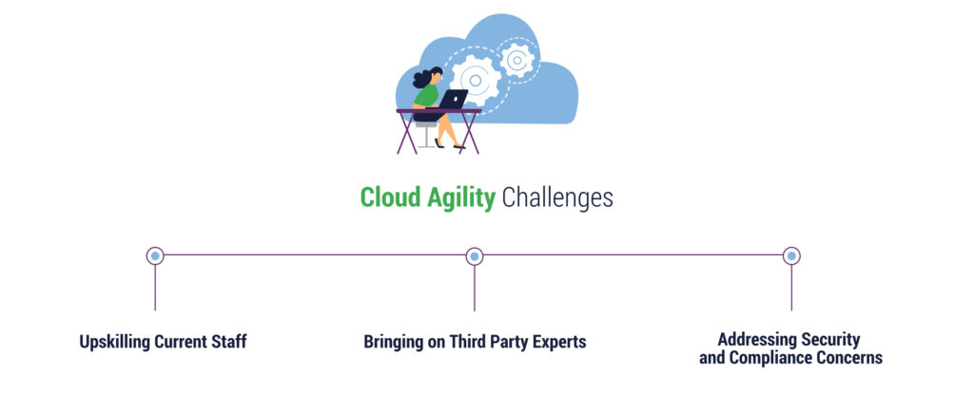
Depending on your in-house skills, you may also need to upskill current staff or bring in new cloud experts to fill cloud skills gaps, manage the cloud environment, and advance new and innovative capabilities, as well as make the most of cloud agility. Businesses also have to address new security and compliance challenges that can arise from moving to cloud.
How to Build Cloud Agility in Your Cloud Environment
You can incorporate cloud agility into your environment by utilizing the following:
Infrastructure as Code (IaC)
Embrace IaC techniques for automating infrastructure provisioning and management through code. Utilize tools like Terraform and AWS CloudFormation to streamline and simplify resource creation and modification as per your requirements.
Continuous Integration/Continuous Deployment (CI/CD)
Set up CI/CD pipelines to automate the software development, testing, and deployment processes. This accelerates the release cycle and guarantees quick, dependable deployment of changes pushed to the production environment.
Multi-Cloud Strategy
Prevent vendor lock-in and enhance flexibility by embracing a multi-cloud approach. This strategy involves leveraging various cloud providers or services to avoid reliance on a single vendor and to capitalize on diverse features and pricing structures.
Cloud Cost Optimization
Ensure ongoing monitoring and cost-efficiency in the cloud through resource optimization, identifying idle resources, and the utilization of cloud cost management tools.
Cloud Native Architecture
Create cloud native applications and services from the ground up. This involves harnessing cloud services and embracing a microservices architecture to develop systems that are:
- Modular
- Scalable
- Exceptionally available
Serverless Computing
Opt for serverless computing platforms like AWS Lambda or Azure Functions to execute code without the need for server provisioning or management. This approach enables automatic scaling and further cost optimization.
Containerization
Employ containerization technologies like Docker and container orchestration platforms such as Kubernetes to package applications and services into portable, isolated units. This ensures uniform deployment across cloud environments.
Security and Compliance Automation
Integrate automated security protocols and compliance assessments. Tools like AWS Security Hub and Azure Security Center prove invaluable for pinpointing and remedying security vulnerabilities while ensuring adherence to compliance standards.
Transform Your Environment and Achieve Cloud Agility with TierPoint
Cloud agility presents an opportunity to organizations, enabling greater innovation, a faster time-to-market, unparalleled scalability, and better cloud ROI. If you’re looking to achieve cloud agility, but want to make sure you don’t miss anything along your digital transformation journey, TierPoint is here for you. Our cloud experts can help you with migration, agility, cost optimization, and more.
Need help during your journey in the cloud? Download our eBook to learn how you can minimize the risk of cloud adoption and maxmize the benefits.

FAQ
What Are the Principles of Cloud Agility?
Cloud agility is a self-service, elastic environment that allows organizations to rapidly deploy their applications while optimizing for costs, prioritizing security, and increasing transparency into the cloud environment.
What Are the Key Components of Cloud Agility?
Some of the key components of cloud agility include resource pooling, scalability, automated provisioning, rapid deployment, and continuous integration/continuous development (CI/CD), often within a self-service portal.
How Do DevOps and Continuous Integration/Continuous Delivery (CI/CD) Contribute to Cloud Agility?
DevOps teams combine software development and IT operations into one department to shorten the application development lifecycle. Often, these teams can employ CI/CD to automate the creation, testing, and deployment of code on an interactive basis. Rapid deployment and departmental efficiencies both greatly contribute to cloud agility.

What is CI/CD?
Last Updated : 12 Dec, 2025

CI/CD represents Continuous Integration and Continuous Delivery/Deployment. It is the backbone of modern DevOps, bridging the gap between development and operations by automating the building, testing, and deployment of applications.
In the past, releasing software was an "event" a high-stress day occurring once a month or quarter. With CI/CD, releasing software becomes a routine, non-event that happens multiple times a day.
Before CI/CD
In the past, software delivery was slow and full of manual work. Developers used to create separate feature branches and worked on them for weeks or even months.

- All these branches were merged at the end, which often caused big conflicts and broken builds. Testing and building the code were also manual, usually done at the final stage, so bugs were discovered very late and were costly to fix.
- Deployment was a long and risky process, taking days or sometimes weeks, because everything was released together in one big update.
- Teams were also divided: developers wrote code, testers tested it, and operations managed servers.
After CI/CD
With CI/CD, the whole process became faster, automated, and more reliable. Developers now commit their code frequently to a shared main branch, which prevents conflicts and ensures smooth integration.

- Automated pipelines run tests, builds, and checks as soon as code is pushed, so errors are caught early. Continuous Delivery makes sure that tested code is automatically packaged and ready for deployment
- While Continuous Deployment takes it a step further by directly releasing to production without manual steps. This means smaller, frequent updates instead of one big risky release.
- Tools like Git, Jenkins, Docker, and Kubernetes automate everything from building to deployment, making the workflow transparent and collaborative. Bugs are fixed quickly, rollbacks are easier, and overall software delivery happens in hours instead of days
The Three Pillars of CI/CD
To master CI/CD, you must understand the subtle but critical differences between the three "Continuous" concepts.
1. Continuous Integration (CI)
- The Goal: Prevent "Integration Hell."
- The Process: Developers merge their changes back to the main branch as often as possible (daily).
- The Automation: Upon every commit, an automated system builds the code and runs unit tests. If a test fails, the build is rejected, and the developer is notified immediately.
2. Continuous Delivery (CD)
- The Goal: Be ready to release at any moment.
- The Process: After CI passes, the code is automatically deployed to a staging/testing environment. Extensive integration and load tests are run.
- The Release: The codebase is always in a deployable state, but the push to production is a manual decision (e.g., a "Deploy" button click by a manager).
3. Continuous Deployment (CD)
- The Goal: Eliminate human intervention.
- The Process: Same as Continuous Delivery, but if all automated tests pass in staging, the code is automatically deployed to production.
- The Requirement: Requires extremely robust, trustworthy automated testing suites
CI Workflow
Below is a pictorial representation of a CI pipeline- the workflow from developers checking in their code to its automated build, test, and final notification of the build status.

When a developer saves (commits) their code to a version control system like Git, the CI pipeline starts. It takes the new changes, builds the project, and runs tests automatically. After that, the server tells the developer if adding the new code to the existing code worked or failed.
This helps find and fix bugs faster, saves developers from doing the same tasks again and again, and allows the team to release updates to customers more often. Studies show that using CI can save developers about 25–30% of their time.
CI and CD Workflow
The below image describes how Continuous Integration combined with Continuous Delivery helps quicken the software delivery process with lower risks and improved quality.

We have seen how Continuous Integration automates the process of building, testing, and packaging the source code as soon as it is committed to the code repository by the developers. After the Continuous Integration (CI) step, the code is deployed to a staging environment.
- In the staging environment, it undergoes further automated testing such as: Acceptance Testing & Regression Testing
- Once tests are successful, the code is deployed to the production environment for the final release.
- If the production deployment is manual, the process is called Continuous Delivery.
- If the production deployment is automated, the process is called Continuous Deployment.
Common CI/CD Tools
CI and CD tools can help team in the development, deployment, and testing, some of the tools are highly recommended for the integration part and some are for the development and management of the testing and related functionality.
Most of the famous tools for the CI and CD is Jenkins. It is open source and it will help to handle all types of work and design a simple CI server to complete the CD hub.
Jenkins Workflow in CI/CD
- Developer Commit: Code is pushed to GitHub/GitLab/Bitbucket.
- Trigger: Jenkins detects the commit (via webhook or polling).
- Build: Jenkins builds the code using tools like Maven, Gradle, or Docker.
- Test: Automated tests are run to verify quality.
- Deploy: Code is deployed to staging or production environments automatically.
- Feedback: Developers get instant notifications of success or failure (via email, Slack, etc.).

